About Intern Project

Zip File Content:

1. Front End Folder

It contains following files.

* + Index.html
  + Index.js
  + Style.css
  + Img folder that contain Imgs

1. Backend Folder

It contains following files

1. Fetch.js : Code for fetching data from <https://api.wazirx.com/> using api and store it in MongoDB database.
2. Index.js: Main Backend file, contains routes
3. Node-packages and json files
4. My Resume:
5. About Project word file

DATABASE USED: MongoDB

* Fetures:
* Switch button for toggling dark theme to light theme.
* Connect TELEGRAM button as Link
* Buy Crypto button as link

1. Dark Theme – BAT Crypto

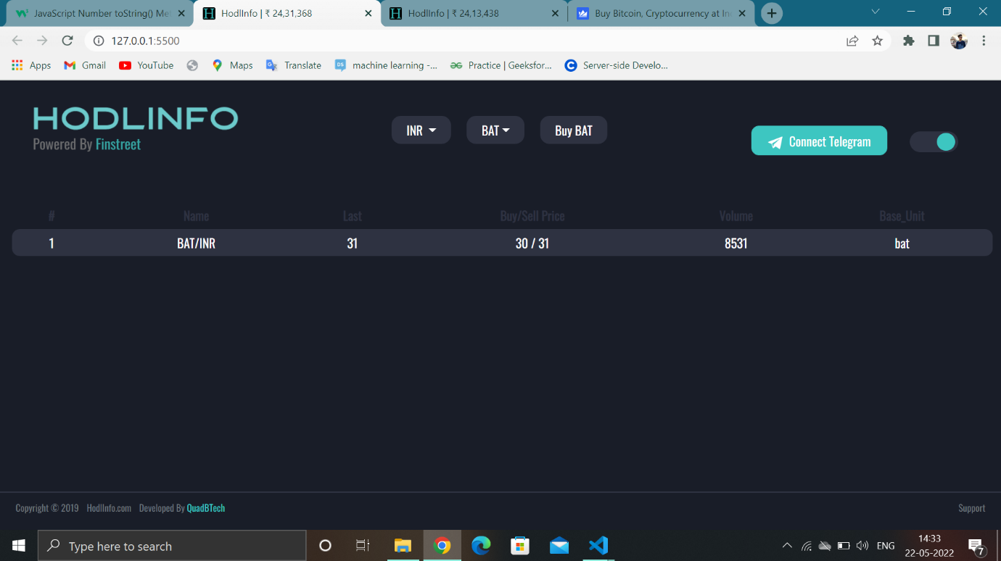

1. Light Theme – BAT Crypto

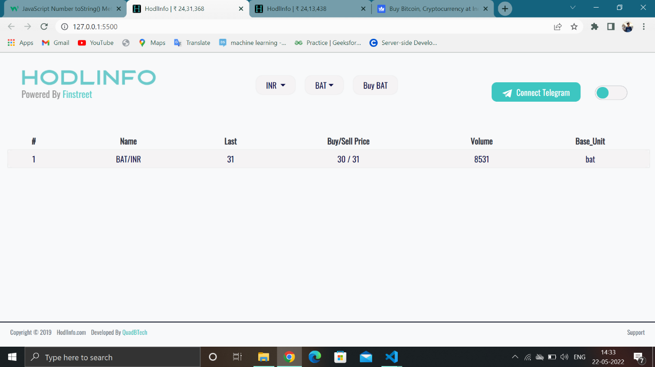

1. BTH Crypto – Dark theme

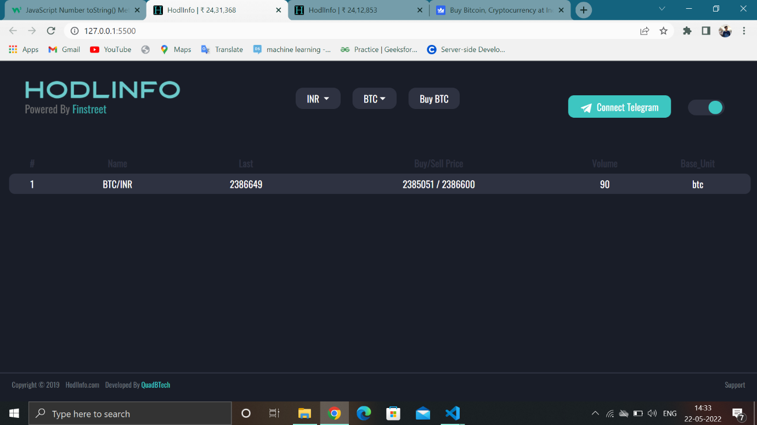

1. ETH Crypto – Dark theme

